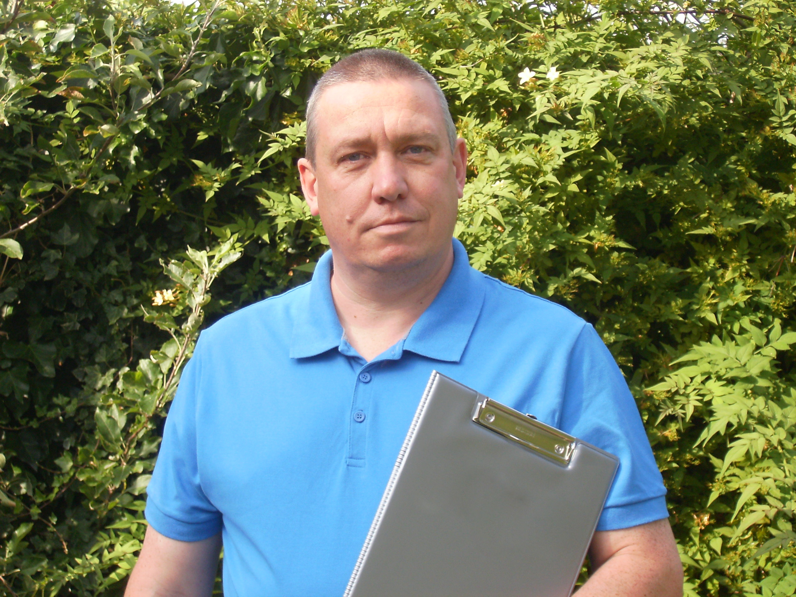
Steve, a bloke in a blue shirt! Raising money for Cancer Research UK

For 27 years Steve worked for the Ministry of Defence, the last seven as part of the Curatorial Team at the Royal Artillery Museum (Firepower) in Woolwich. It was in 2014 that he had the idea to create Steve Hookins Historical Presentations.
His presentations are based on tours and lectures he developed at Firepower. He is irreverent and light hearted on some subjects, thought provoking and serious on others. Steve’s style, a mixture of historical fact, anecdotes and humor has been described as “quick fire history” and because his presentations are un-scripted, no two are ever the same!
He has led battlefield tours to Belgium and France accompanying both military personnel and civilians, and even Arsenal Football club. Steve has also worked as an historical advisor on radio and television programs such as “Who do you think you are?”, “Bargain Hunt” and John Sergeant’s “Royal Greenwich” in 2012.
He is a regular at the Royal Engineers museum’s Christmas Event appearing as various members of the civil defence volunteers. In 2014 his first book, “My Grandad, the Air Raid Warden” was published and in 2016 he was awarded the Imperial Service Medal; he now works for the NHS. In 2019 he was part of a winning team on the TV game show, Tenable.
In his spare time he has undertaken a quest to discover the perfect dry, French, white wine; his research is ongoing!

